Science as a Human Endeavour (H) and Science Understanding (U)

When planning for teaching and learning that explores the intersection between Science as a Human Endeavour and Science Understanding, teachers
could focus on how scientific knowledge develops over time in response to human curiosity and challenges. The ‘what’ becomes more meaningful and complex
when exploring its natural overlap with the ‘why’ and the ‘who’.

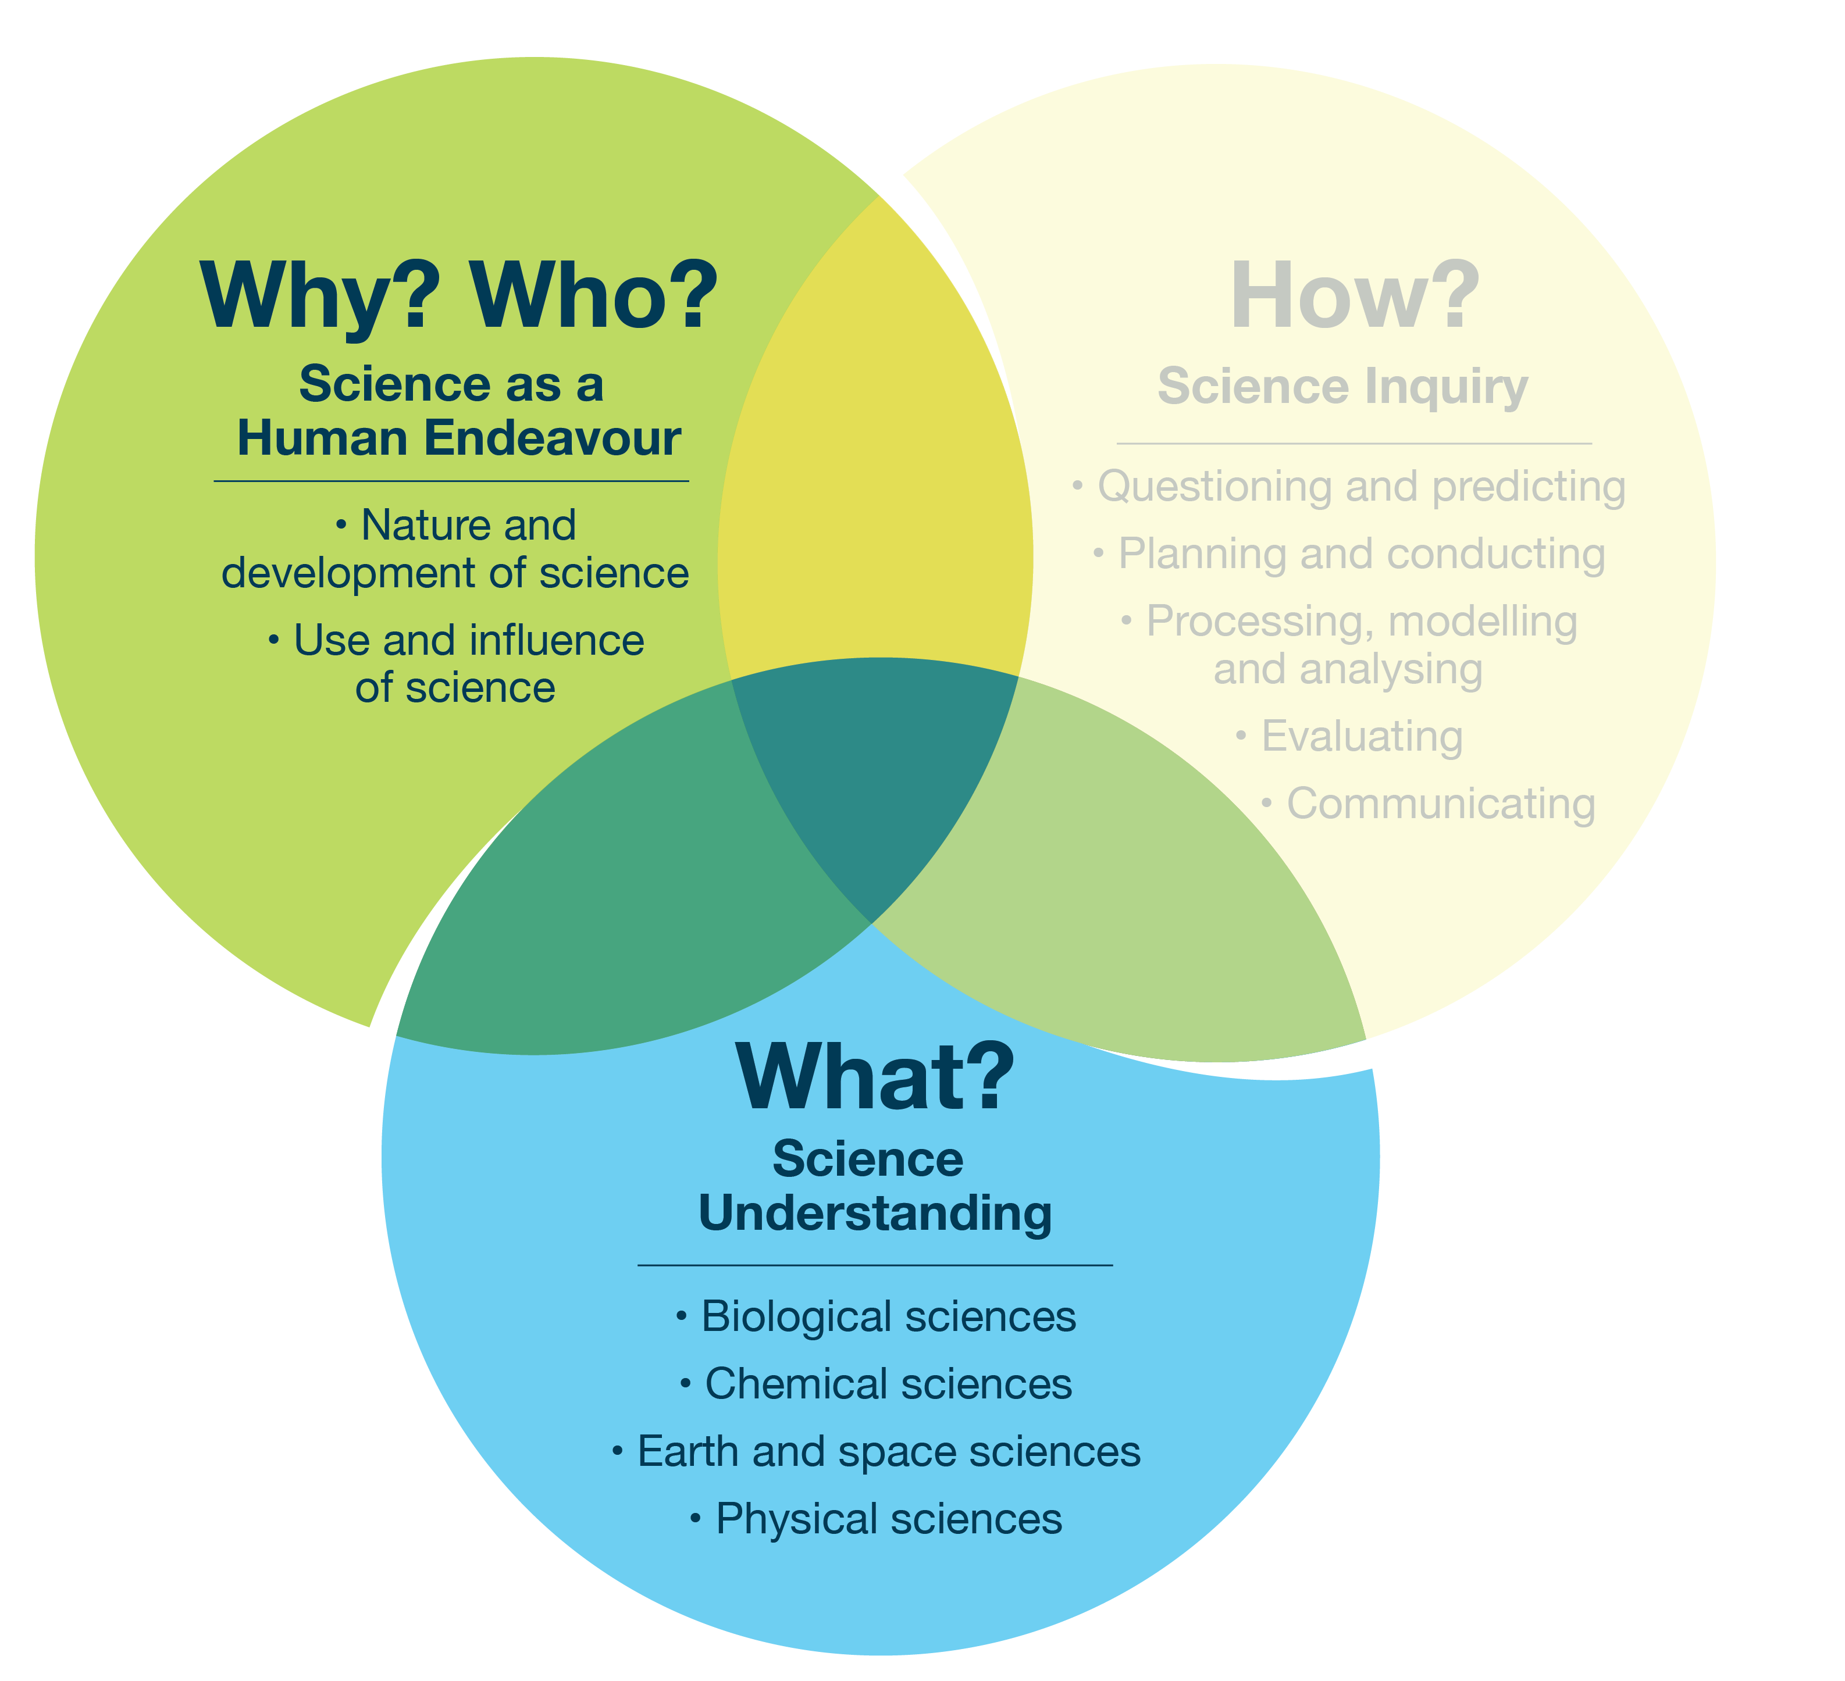
Focus 2.1 – Interconnecting Science as a Human Endeavour
and Science Understanding

Example topic – multiple strands
Students might compare the differences between melting and burning food, see which of these processes can be reversed, and consider how chefs and food scientists use this knowledge to create the best-tasting food.
Possible focus question | Curriculum alignment
How does cooking sugar change it, and how do chefs use their knowledge about this process to make different tastes and textures? | H link: Considering how cultural traditions, values and creativity shape the use of food chemistry in cooking  U link: Understanding physical and chemical changes in sugar and their effects on taste and texture  H–U overall link: Students reflect on how societal needs and challenges guide the use of scientific understanding in food preparation
Further examples on the next page.

Possible focus question | Curriculum alignment
Why can some cooking changes be reversed (like melting chocolate), but others cannot (like cooking eggs), and how does this affect how we cook food? | H link: Considering how practical, cultural and ethical factors influence acceptance of cooking processes and technologies  U link: Understanding reversible and irreversible changes in cooking  H–U overall link: Students explore how understanding reversible and irreversible cooking changes, together with culture, ethics and practical needs, informs how we cook food
Possible focus question | Curriculum alignment
How have people’s ideas and problems helped scientists learn about cooking, so they can make new foods and develop better ways to cook? | H link: Considering how societal challenges, innovation, and ethics drive the use of scientific knowledge in food technology  U link: Understanding physical and chemical changes in cooking and their role in technological development  H–U overall link: Students analyse the roles of science and society in improving foods and cooking methods

